Homework Answers
Lecture 13
Confidence Interval for a Mean (Population Std. Deviation Known)

Problem: For a certain sample of size n = 64, the sample mean is .
We know the population standard deviation is = 8.
Set up a 99% confidence interval for the population mean, µ.

p = 0.99
α = 1 – 0.99 = 0.01
α/2 = .005
Area in lower tail = 0.005
Area in upper tail = 0.005
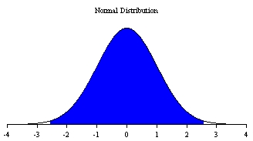

z_{L} = norm.s.inv (.005) = –2.576
z_{U} = norm.s.inv (.995) = 2.576

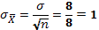

Lower limit of CI = = 85 – (2.576 × 1) = 82.424
Upper limit of CI = = 85 + (2.576 × 1) = 87.576

